The Fourier Transform allows one to transform a signal from the time to the frequency domain, and vice versa:

$$f\left(t\right) \underset{↔}{} F(ω)$$

This worksheet explores some interesting properties of the Fourier Transform by using web-based MoCChA worksheets.

1. Listen to the audio recordings saved here: <https://goo.gl/3ETJuY>. Both files are for musical instruments - a recorder and a trombone, respectively.   
     
   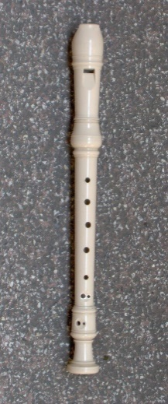 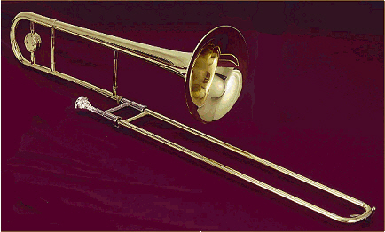  
   (recorder) (trombone)
2. Shown below is the time-dependent audio recording (intensity versus time) for the *recorder*.   
   (a) Observe the audio signal f(t). What is the frequency of the vibration, i.e. how often does it oscillate per second? (1/second = 1 Hz)  
     
     
     
     
     
     
     
     
     
   (b) Based on your finding from (a), hypothesize what the frequency spectrum |f()|2 of the recording might look like. Sketch it in the figure below.  
     
     
     
     
     
     
     
     
     
     
     
     
     
     
     
     
     
     
     
     
     
     
     
     
     
     
   (c) Open the MoCChA notebook <http://hub-dev.crc.pitt.edu> -> Chem1000/fourier.ipynb and test your hypothesis by calculating the Fourier transform of the *recorder.wav* recording. Does your hypothesis agree with the numerically exact spectrum? If there are qualitative differences, can you explain them?

■ = ________ Hz  
  
⬥ = 2 = _____ Hz

0

0.01

0.02

Intensity

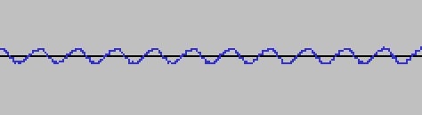

Time (sec)

*Let’s pause here and discuss our findings in class.*

1. (a) Hypothesize how the time-dependent signal f(t) and its Fourier transform |f()|2 might differ for between the trombone recording (*trombone.wav*) and that of the recorder.  
     
     
     
     
     
     
      
     
     
     
     
     
     
     
     
     
     
     
     
     
     
     
     
     
   (b) Here is the time-dependent signal f(t) for the trombone. Compare with your expectations.   
     
     
     
     
     
      
     
     
     
     
     
     
     
     
     
     
     
     
   (c) Open the MoCChA notebook <http://hub-dev.crc.pitt.edu> -> Chem1000/fourier.ipynb and test your hypothesis by calculating the Fourier transform of the *recorder.wav* recording. Does your hypothesis agree with the numerically exact f(w)? If there are significant differences, can you explain them?

Intensity

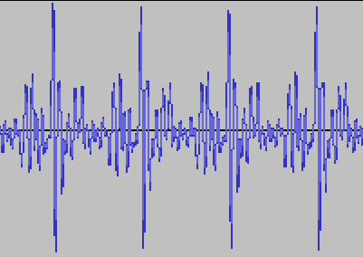

■ = ________ Hz  
  
⬥ = 2 = _____ Hz

Time (sec)

0.04

0.02

0

*Let’s pause here and discuss our findings in class.*

**Team Assignment –continue outside of class if necessary***Turn in your solutions by Wednesday, November 29. (24 Points)*

1. Below are four signals in the time domain, f1(t) through f4(t). They are actually the same signal cut off after different amounts of time, $Δt_{1}$ through $Δt_{4}$.   
     
     
     
     
     
     
     
     
     
     
     
     
     
     
     
     
     
     
     
     
     
     
     
     
     
     
     
     
   (a) Observe the f(t) graphs and estimate the frequency of the signal.  
     
     
   1 = _________ Hz  
     
   2 = _________ Hz  
     
   3 = _________ Hz  
     
   4 = _________ Hz  
     
     
   (b) Hypothesize: What should the Fourier spectra of signals f1(t) through f4(t) look like? Sketch your answers.  
     
     
     
     
     
     
     
     
     
     
     
     
     
     
     
     
     
     
     
   (c) Open the MoCChA notebook via <http://hub-dev.crc.pitt.edu> -> Chem1000/fourier**2**.ipynb to test your hypothesis. Sketch the Fourier spectra |f1(w)|2 through |f4(w)|2 below:  
     
     
     
     
     
     
     
     
     
     
     
     
     
     
     
     
     
     
     
     
     
     
     
   (d) How do the exact spectra compare to your initial hypothesis? If necessary, refine your hypothesis.  
     
     
     
     
     
     
     
     
     
     
     
     
     
     
     
     
     
     
     
     
     
     
     
   (e) The “full width at half maximum” (FWHM) of a signal is defined as the width of a peak at half its height, as shown below:  
     
   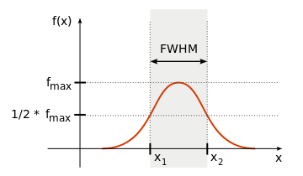  
     
     
     
   Record the FWHM of Fourier spectra |f1()|2 through |f4()|2 into the table below. Also record the



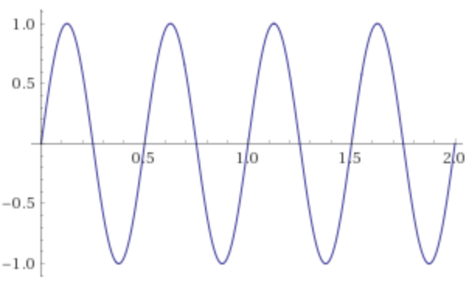

F4(t): $Δt_{4}=2$

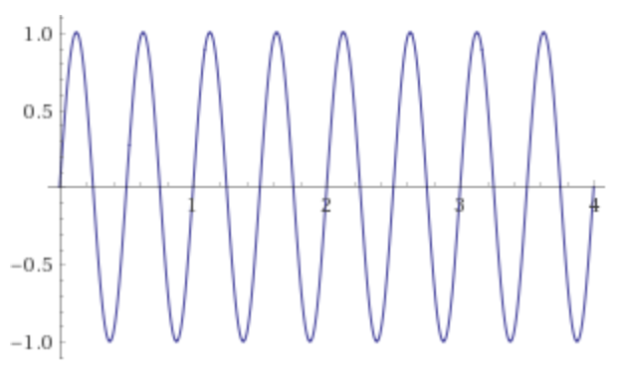

f3(t): $Δt_{3}=4$

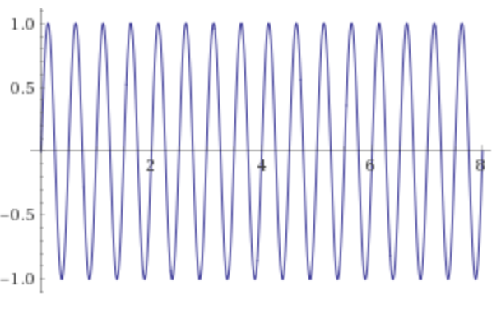

f2(t): $Δt_{2}=8$

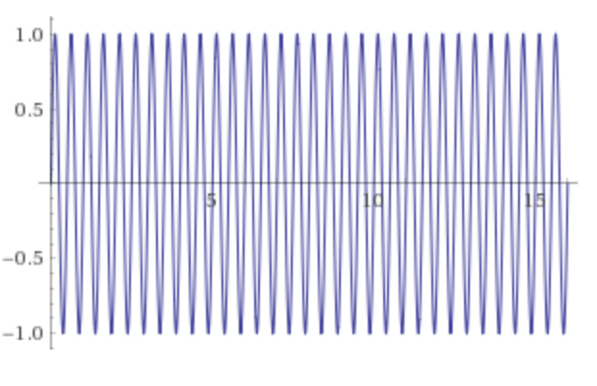

f1(t): $Δt_{1}=16$

|  |  |
| --- | --- |
| $Δt$ [in sec] (length time-domain signal) | $Δω$ [in Hz] (FWHM of frequency-domain signal) |
| 1 |  |
|  |  |
|  |  |
|  |  |
|  |  |

lengths of the time-domain signals.

1. Sketch a plot of $Δω$ versus $Δt$:
2. Observe the relation between $Δω$ and $Δt$. Can you formulate it in the form of a function, e.g. $Δω=a⋅Δt+b$ or $Δω=\frac{a}{Δt}+b$?
3. Our observations have discovered a special form of the Uncertainty Relation, also called *Heisenberg’s Uncertainty Principle:*  
     
     
     
     
     
     
   where h is a fundamental constant called Planck’s Constant and has value $h≈6⋅{10}^{-34} J⋅s$.

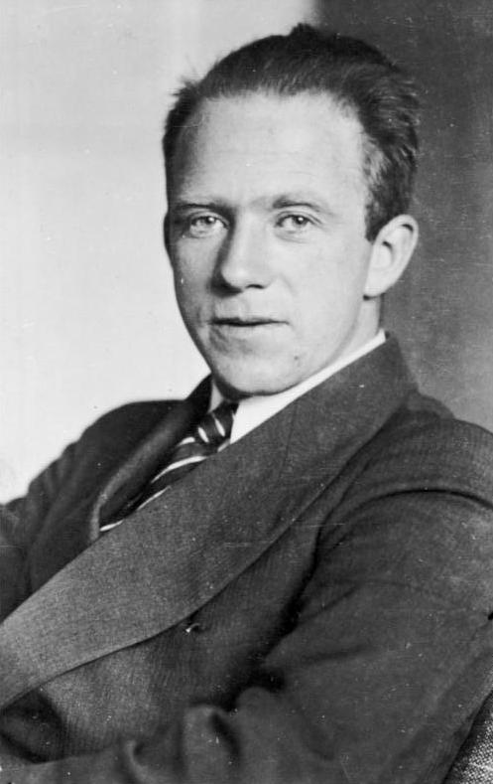

*Werner Heisenberg received the 1932 Nobel Prize in Physics for his contributions to the formulation of Quantum Mechanics.*

$Δω⋅Δt ≥ \frac{h}{2π}$

1. Hypothesize: What could be consequences of the Uncertainty Principle on measuring observables in Chemistry? *Discuss in your team.*
2. Open the MoCChA notebook <http://hub-dev.crc.pitt.edu> -> Chem1000/fourier**3**.ipynb to investigate the shape of the Fourier spectrum of a signal in dependence of the duration of the signal.  
     
     
   (a) Observe the shape and the features of |f(w)|2 when the signal has a long duration (e.g. T = 16). Sketch the result below:  
     
     
     
     
     
     
     
     
     
     
     
     
     
   (b) Observe the shape of |f(w)|2 as the signal becomes shorter (e.g. T = 8, 4, 2). Sketch the results below:  
     
     
     
     
     
     
     
     
     
     
     
     
     
     
     
     
     
   (c) Compare your observations with your initial hypothesis. How does the Uncertainty Principle impact the conversion between f(t) and |f(w)|2?